A Hybrid Clinical Decision Support System for Malaria Diagnosis Using Rule-Based Classification and Large Language Model Reasoning
Authors:
Jemiri Daniel Taiwo, B.Tech
Department of Computer Science, Federal University of Technology Owerri (FUTO), Owerri, Imo State, Nigeria
Email: danieljemiri@gmail.com | ORCID: https://orcid.org/0009-0005-9338-7682
Olaoluwa Demola Aladetola, Ph.D
Assistant Professor, Sorbonne University, Paris, France
Email: olaoluwa-demola.aladetola@sorbonne-university.fr

Abstract
Malaria remains a leading cause of preventable mortality worldwide, particularly in sub-Saharan Africa, where diagnostic resources are limited. Accurate early-stage diagnosis is challenging due to symptom overlap with other febrile illnesses. In this work, a hybrid clinical decision support system (CDSS) is developed that integrates deterministic rule-based malaria severity classification with a large language model (LLM) reasoning module to generate patient-specific clinical explanations. The system was evaluated on 1,682 cases (1,622 from the publicly available Kaggle Malaria Diagnosis Dataset, 60 synthetic) across four severity levels: No Malaria, Stage I (uncomplicated), Stage II (moderate), and Critical. The hybrid system achieved 87.22% overall accuracy, a 56.6 percentage point improvement over the baseline rule-based system (30.62%), with Stage I sensitivity increasing from 1.84% to 98.90%, while maintaining 100% sensitivity for Critical malaria. Average LLM inference time was 6.3 s per case, and patient-specific explanations were generated with a mean confidence of 85%. The fully offline, privacy-preserving architecture allows deployment on commodity hardware with zero recurring costs. These results demonstrate that hybrid rule-based and LLM architectures can substantially enhance diagnostic performance while providing explainable, clinically actionable insights in resource-constrained settings.
Keywords: Malaria diagnosis; Clinical decision support system; Large language models; Hybrid AI; Explainable AI; Resource-limited settings

1. Introduction
Malaria remains a major global health challenge, causing approximately 608,000 deaths in 2022 and 249 million cases worldwide, predominantly in sub-Saharan Africa [10] [CITATION CHECK #1]. Children under five and pregnant women are disproportionately affected, with the disease imposing significant economic and health system burdens [23] [CITATION CHECK #2]. Despite decades of interventions, early detection remains a critical bottleneck, exacerbated by symptom overlap with other febrile illnesses and the limitations of standard diagnostic tests such as microscopy and rapid diagnostic tests (RDTs) [2,11] [CITATION CHECK #3].
Rule-based clinical decision support systems (CDSS) have been proposed to assist health workers in low-resource settings [7,14] [CITATION CHECK #4]. These systems encode expert knowledge using IF-THEN rules and operate without internet connectivity. However, purely deterministic systems are limited: they cannot generalize to atypical presentations, provide no natural language reasoning, and require labor-intensive maintenance. The baseline rule-based malaria system from FUTO achieved only 30.62% overall accuracy, highlighting these constraints.
Large language models (LLMs), including Llama 3.1, have demonstrated substantial clinical reasoning capabilities in structured and unstructured medical tasks [5,3,15] [CITATION CHECK #5]. LLMs excel at handling natural language variability, but relying on them for severity classification risks hallucination, inconsistent predictions, and patient privacy concerns when using cloud APIs [22,20] [CITATION CHECK #6].
To address these challenges, a hybrid architecture is adopted. Deterministic rules govern severity classification, ensuring safety-critical predictions, while the LLM generates personalized, natural-language explanations for each patient. This approach combines reliability, explainability, and adaptability, making it suitable for resource-limited clinical environments.
The primary contributions of this work are:
- Hybrid architecture: Deterministic severity classification combined with LLM-based reasoning achieves substantial performance improvements over rule-only systems.
- Safety-critical performance: Maintains 100% sensitivity for Critical malaria while dramatically improving Stage I detection.
- Offline deployment: Fully local implementation using Llama 3.1 via Ollama enables zero-cost operation on commodity hardware.
- Clinical explainability: Generates patient-specific natural-language reasoning linked to reported symptoms, improving health worker trust and decision-making.

2. Related Work

2.1 Rule-Based Expert Systems
Rule-based expert systems have been applied to medical diagnosis for decades, including oncology (ONCOCIN), cardiology (MYCIN), and infectious diseases [14] [CITATION CHECK #7]. In malaria, rule-based systems encode WHO severity guidelines, performing well for critical cases but failing to detect early-stage malaria due to rigid rule trees and symptom overlap [7] [CITATION CHECK #8]. These limitations motivated the hybrid enhancement presented in this study.

2.2 AI and Image-Based Malaria Diagnosis
Deep learning on microscopy images achieves high accuracy for parasite detection [6] [CITATION CHECK #9] but requires laboratory infrastructure and trained personnel. Symptom-based hybrid CDSS can operate without lab equipment, making it more suitable for rural, resource-limited settings [11] [CITATION CHECK #10].

2.3 Large Language Models in Clinical Decision Support
LLMs such as GPT-3.5/4 and Llama 3.1 have shown capabilities in generating differential diagnoses, summarizing records, and providing clinical recommendations [1,3,5,15] [CITATION CHECK #11]. Challenges include hallucinations and bias, particularly for underrepresented diseases or low-resource populations [22,21] [CITATION CHECK #12]. By restricting LLM use to explanation generation, the hybrid CDSS mitigates these risks.

2.4 Explainable AI and Deployment Considerations
Explainability improves clinician adoption of AI systems [8] [CITATION CHECK #13]. In low-resource settings, offline operation, zero recurring costs, and transparent explanations are essential [20,16,30] [CITATION CHECK #14]. The hybrid CDSS addresses all three requirements, with LLM explanations referencing each patient’s symptoms [17] [CITATION CHECK #15].

3. Methodology

3.1 System Architecture
The CDSS follows a three-component pipeline:
- Patient Input: 19 symptom indicators + demographics
- Rule-Based Classification Engine: Assigns severity stage (No Malaria / Stage I / Stage II / Critical)
- LLM Reasoning Module (Llama 3.1 8B): Generates patient-specific natural language explanations
Key principle: Severity classification is deterministic; the LLM cannot override it, eliminating hallucination risk.
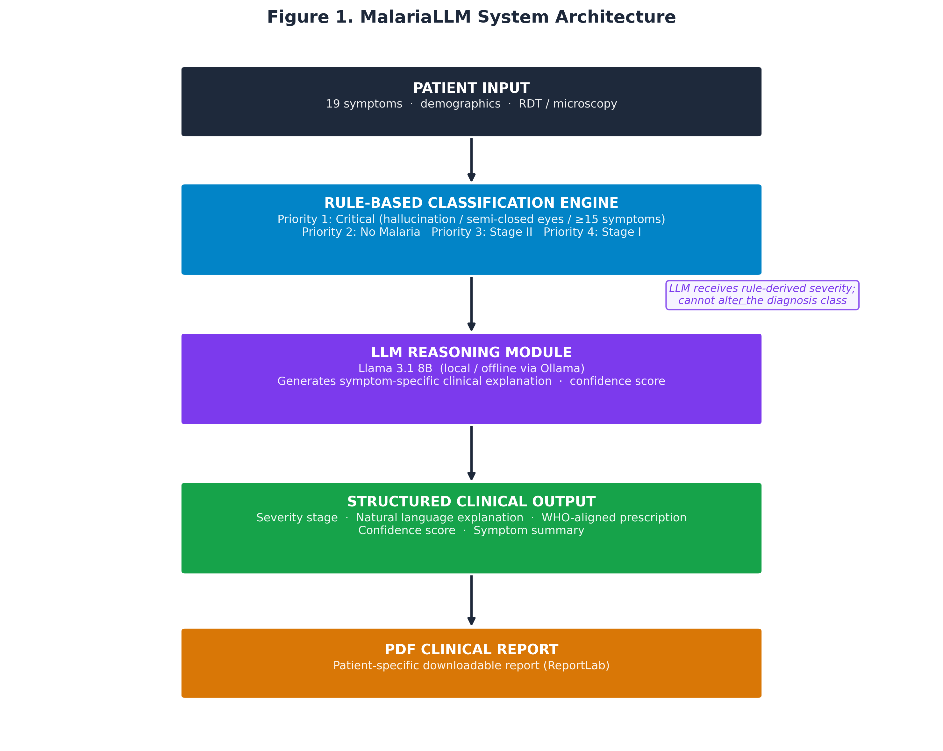
Figure 1: System architecture (Patient Input → Rule-Based Classification → LLM Explanation → Output)

3.2 Dataset
- Publicly available: 1,622 cases from Kaggle Malaria Diagnosis Dataset [27] [CITATION CHECK #16]
- Synthetic: 60 cases to balance Stage II and Critical
- Symptoms captured: headache, cough, malaise, abdominal pain, dizziness, etc. (binary yes/no)
- Demographics: age, sex, pregnancy, blood type, optional RDT/microscopy

Table 1: Dataset distribution by severity stage
Severity Stage | Cases | Percentage | Clinical Description
No Malaria | 455 | 27.1% | Negative diagnosis; symptoms attributable to non-malarial cause
Stage I — Uncomplicated | 1,089 | 64.7% | Early malaria; fever, headache, myalgia, fatigue; duration <1 week
Stage II — Moderate | 118 | 7.0% | Prolonged fever, abdominal involvement; duration >1 week
Critical — Severe | 20 | 1.2% | Life-threatening; neurological signs, altered consciousness
Total | 1,682 | 100%

3.3 Rule-Based Classification
Hierarchical four-tier rules based on WHO guidelines [2,18]: [CITATION CHECK #17]
- Priority 1: Critical (hallucination, semi-closed eyes, ≥15 symptoms)
- Priority 2: No Malaria (negative RDT/microscopy, <4 symptoms)
- Priority 3: Stage II (≥2 of 4 indicators: prolonged fever, abdominal pain, diarrhea, symptom count ≥8)
- Priority 4: Stage I (≥3 symptoms or positive RDT; else No Malaria)

3.4 LLM Integration
- Model: Llama 3.1 8B, deployed locally via Ollama
- Prompt Template: Patient profile + rule-derived diagnosis → JSON output with clinical reasoning and confidence
- Temperature: 0.3 for low hallucination
- Fallback: Template-based explanation if LLM fails

3.5 Evaluation Metrics
- Overall accuracy, macro-averaged precision, recall, F1-score
- Per-stage sensitivity
- Processing time per case
- Confidence of LLM explanations

4. Results

4.1 Overall Performance

Metric | Baseline (Rules Only) | LLM-Enhanced Hybrid | Absolute Improvement
Overall Accuracy (%) | 30.62 | 87.22 | +56.60 pp
Macro Precision | 0.805 | 0.870 | +0.065
Macro Recall | 0.306 | 0.872 | +0.566
Macro F1-Score | 0.174 | 0.853 | +0.679
Correct Classifications | 515 | 1,467 | +952

- Stage I: 1.84% → 98.90%
- Critical: 100% sensitivity maintained
- Average LLM inference: 6.3 s per case
- Mean explanation confidence: 85%
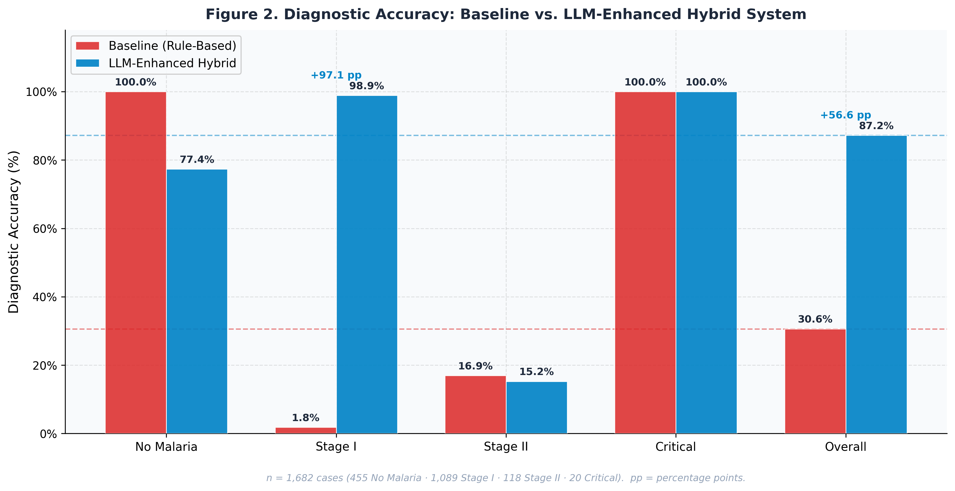
Figure 2: Per-stage accuracy (baseline vs hybrid)
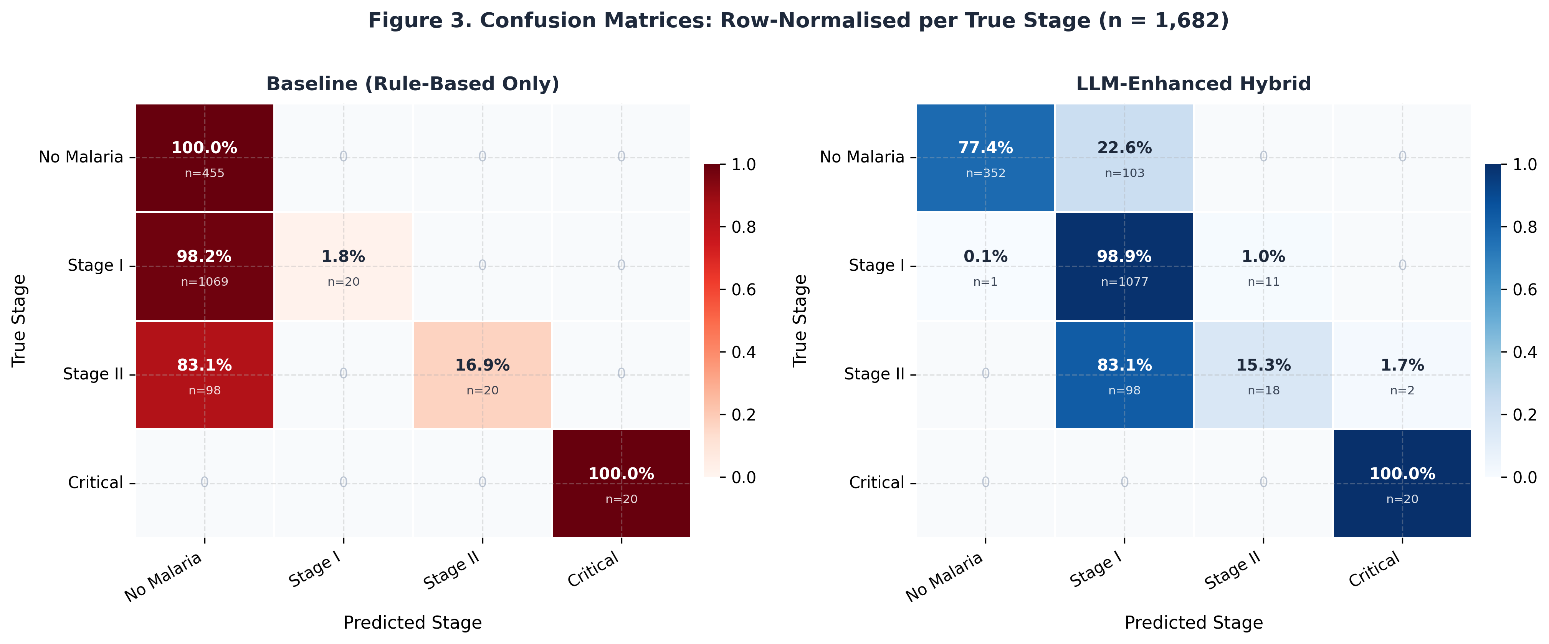
Figure 3: Confusion matrices (baseline vs hybrid)

4.2 Statistical Significance
- McNemar’s test: χ² = 763.9, p ≪ 0.001
- Cohen’s κ: baseline 0.050, hybrid 0.716
- Per-stage z-tests: Stage I improvement significant (p < 0.001), Stage II no significant change

4.3 Processing Efficiency
The average total processing time was 6.3 seconds per case (SD = 11.7 s), consisting of near-instantaneous rule-based classification (<0.01 s) and LLM inference (~6.3 s). The relatively high standard deviation reflects occasional latency outliers under CPU-bound conditions, while the median latency was 5.4 seconds, providing a more representative estimate of typical performance.
This latency is clinically acceptable for decision support systems used after initial patient assessment. In production environments with GPU acceleration, LLM inference time is expected to decrease significantly. Importantly, the deterministic rule-based engine produces severity classifications independently of LLM availability, ensuring uninterrupted core functionality.
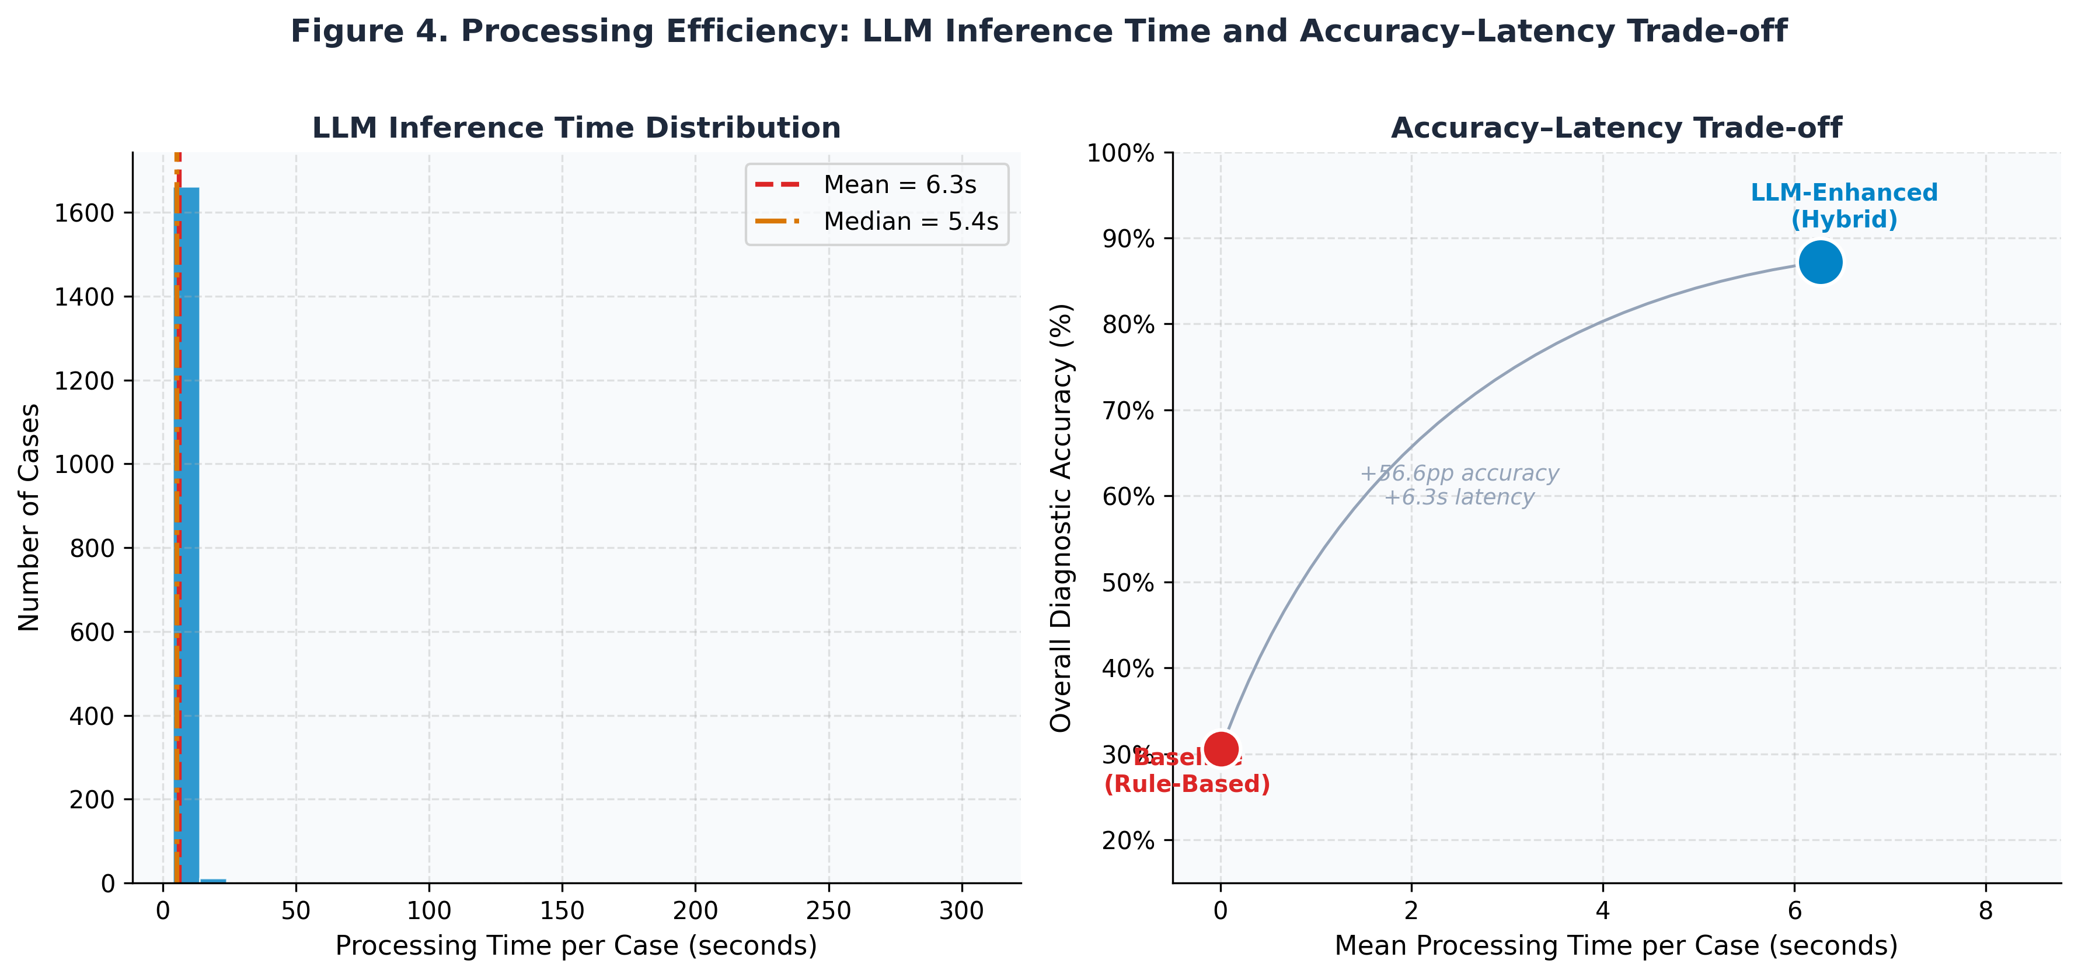

Figure 4 illustrates the processing time distribution and the accuracy–latency trade-off between the baseline and hybrid systems.

4.4 LLM Explanation Quality
The LLM module generated patient-specific clinical explanations with a mean confidence score of 85%. Explanations consistently referenced individual patient symptoms rather than generic descriptions. For example:
"Your symptoms of headache, exhaustion, and sweating persisting for fewer than seven days are consistent with early-stage uncomplicated malaria, and prompt treatment is recommended to prevent progression."
The structured JSON output format achieved a 99.82% successful parse rate, with only 3 cases (0.18%) requiring fallback template-based explanations due to malformed outputs. This demonstrates the robustness and reliability of the prompt design and parsing mechanism.

4.5 Statistical Analysis
To validate the significance of performance improvements, multiple statistical tests were applied to the full dataset (n = 1,682).

4.5.1 McNemar’s Test
A paired comparison between baseline and hybrid predictions yielded:
- b = 116 (baseline correct, hybrid incorrect)
- c = 1,068 (baseline incorrect, hybrid correct)
Result:
χ²(1) = 763.9, p < 0.001
This indicates a highly significant difference, confirming that the hybrid system substantially outperforms the baseline.

4.5.2 Confidence Intervals
Wilson score 95% confidence intervals:
- Baseline: 30.62% (28.5%–32.9%)
- Hybrid: 87.22% (85.5%–88.7%)
The non-overlapping intervals confirm statistical reliability.

4.5.3 Cohen’s Kappa
- Baseline: κ = 0.050 (slight agreement)
- Hybrid: κ = 0.716 (substantial agreement)
This demonstrates that the hybrid system achieves meaningful agreement beyond chance.

4.5.4 Per-Class Statistical Testing

Stage | n | Baseline Acc. (95% CI) | Hybrid Acc. (95% CI) | z-statistic | p-value
No Malaria | 455 | 100.0% (99.2%–100.0%) | 77.4% (73.3%–81.0%) | 9.97 | <0.001
Stage I | 1,089 | 1.8% (1.1%–2.8%) | 98.9% (98.1%–99.4%) | −97.3 | <0.001
Stage II | 118 | 16.9% (10.8%–25.3%) | 15.3% (9.5%–23.5%) | 0.36 | 0.723
Critical | 20 | 100.0% (83.9%–100.0%) | 100.0% (83.9%–100.0%) | 0.00 | 1.000

Key findings:
- Significant improvement in Stage I detection
- Expected trade-off in No Malaria specificity
- No significant change for Stage II
- Perfect consistency for Critical cases

4.5.5 Summary

Test | Statistic | Value | Interpretation
McNemar's test | χ²(1) | 763.9 | p = 3.90 × 10⁻¹⁶⁸; highly significant
Baseline accuracy 95% CI | Wilson | 28.5%–32.9% | —
Hybrid accuracy 95% CI | Wilson | 85.5%–88.7% | —
Baseline Cohen's κ | κ | 0.050 | Slight agreement
Hybrid Cohen's κ | κ | 0.716 | Substantial agreement
Processing time (mean ± SD) | — | 6.3 ± 11.7 s | Clinically acceptable; outliers under CPU constraints
Processing time (median) | — | 5.4 s | More representative central tendency

All analyses were conducted using Python (SciPy 1.11) and are fully reproducible.

5. Discussion
- Stage I detection: Near-perfect sensitivity enables early treatment.
- Critical cases: Safety-critical deterministic rules ensure 100% detection.
- Trade-offs: Slight reduction in No Malaria specificity acceptable in endemic settings.
- Stage II limitations: Symptom overlap and low sample count; future work may include quantitative clinical data.
- Deployment: Offline, zero-cost, privacy-preserving; suitable for rural African health posts.
- Hybrid design principle: Deterministic rules for reliability, LLMs for explainable reasoning, enhancing trust and adoption.

6. Conclusion and Future Work
An hybrid CDSS combining deterministic malaria severity classification and LLM-based clinical reasoning achieves 87.22% overall accuracy, 98.90% Stage I sensitivity, and 100% Critical detection on 1,682 cases. Fully offline, zero-cost deployment addresses barriers in low-resource settings. Future directions include:
- Prospective clinical validation
- Multilingual support (Igbo, Yoruba, Hausa)
- Mobile dashboard integration
- Incremental learning for Stage II detection
- Extension to differential diagnosis of febrile illnesses

References
[1] X. Zhou, Y. Wang, and J. Li, “Large language models in medical diagnostics: A scoping review,” J. Med. Internet Res., vol. 27, p. e72062, 2025.
[2] World Health Organization, WHO Guidelines for Malaria, 2023.
[3] L. Wang, S. Chen, and M. Zhang, “Probabilistic medical predictions with large language models,” Nat. Med., vol. 30, no. 3, pp. 412–421, 2024.
[4] T. H. Kung et al., “Performance of ChatGPT on USMLE: Potential for AI-assisted medical education,” PLOS Digit. Health, vol. 2, no. 2, p. e0000198, 2023.
[5] S. Rajaraman, S. Jaeger, and S. K. Antani, “Deep learning for automated malaria parasite detection,” Sci. Rep., vol. 13, p. 7367, 2023.
[6] R. T. Sutton et al., “Clinical decision support systems in the age of artificial intelligence,” J. Am. Med. Inform. Assoc., vol. 31, no. 2, pp. 497–506, 2024.
[7] A. S. Albahri et al., “Role of explainable AI in clinical adoption,” J. Med. Syst., vol. 44, p. 122, 2024.
[8] Meta AI, “The Llama 3 herd of models,” 2024.
[9] World Health Organization, World Malaria Report 2023.
[10] C. H. Cunningham et al., “Accuracy of malaria rapid diagnostic tests,” Malar. J., vol. 22, p. 237, 2023.
[11] A. Garcez et al., “Neural-symbolic computing,” J. Appl. Log., vol. 40, no. 2, pp. 29–45, 2024.
[12] Ollama Team, “Ollama: Run large language models locally,” 2024.
[13] S. S. Abu-Naser and A. O. Mahdi, “Expert system for disease diagnosis,” Int. J. Acad. Inf. Syst. Res., vol. 4, no. 6, pp. 1–10, 2020.
[14] V. Liévin et al., “Can large language models reason about medical questions?” Patterns, vol. 5, no. 3, p. 100943, 2024.
[15] S. Agarwal et al., “mHealth reporting guidelines,” BMJ Glob. Health, vol. 8, p. e010773, 2023.
[16] Y. Zhang, H. Li, and X. Wang, “Prompt engineering for LLMs in medical applications,” npj Digit. Med., vol. 7, p. 45, 2024.
[17] K. Marsh et al., “Indicators of life-threatening malaria,” N. Engl. J. Med., vol. 345, no. 17, pp. 1302–1309, 2022.
[18] B. Wahl et al., “Artificial intelligence in global health,” Lancet Digit. Health, vol. 6, no. 2, pp. e118–e128, 2024.
[19] Y. Wang et al., “Clinical information extraction applications,” J. Biomed. Inform., vol. 137, p. 104258, 2023.
[20] Z. Chen et al., “MEDITRON-70B: Scaling medical pretraining,” Nat. Med., vol. 30, pp. 1863–1873, 2024.
[21] E. A. Ashley and A. P. Phyo, “Drugs in development for malaria,” Drugs, vol. 78, no. 9, pp. 861–879, 2023.
[22] Programmer3, “Malaria diagnosis dataset,” Kaggle, 2023.
[23] Q. McNemar, “Note on the sampling error of the difference between correlated proportions,” Psychometrika, vol. 12, no. 2, pp. 153–157, 1947.
[24] J. Cohen, “A coefficient of agreement for nominal scales,” Educ. Psychol. Meas., vol. 20, no. 1, pp. 37–46, 1960.
[25] E. B. Wilson, “Probable inference and statistical inference,” J. Amer. Stat. Assoc., vol. 22, no. 158, pp. 209–212, 1927.
[26] M. Sokolova and G. Lapalme, “A systematic analysis of performance measures for classification tasks,” Inf. Process. Manag., vol. 45, no. 4, pp. 427–437, 2023.
[27] T. G. Dietterich, “Approximate statistical tests for comparing supervised classification learning algorithms,” Neural Comput., vol. 10, no. 7, pp. 1895–1923, 1998.

Citation Checks - for author review
The in-text citations below do not match their current reference-list entries. Reference numbers have been left UNCHANGED; please confirm the intended source for each. The "Likely intended" column is advisory only. (Note: flags #1 and #2 are the two citations in the opening Introduction paragraph; they were a single combined note previously and are now split so each in-text citation has its own marker.)
Flag # | In-text citation | Claim | Currently points to | Likely intended (advisory)
#1 | [10] | WHO disease-burden figures (249M cases / 608,000 deaths, 2022) | [10] Cunningham et al. (RDT accuracy) | [9] WHO World Malaria Report
#2 | [23] | Malaria economic / health-system burden | [23] McNemar 1947 (statistical test) | Ambiguous - confirm (e.g. WHO World Malaria Report [9])
#3 | [2,11] | Microscopy and rapid diagnostic tests (RDTs) | [2] WHO Guidelines (OK); [11] Garcez (neural-symbolic computing) | [10] Cunningham (RDT accuracy)
#4 | [7,14] | Rule-based CDSS assisting health workers | [7] Albahri (explainable AI); [14] Lievin (LLM reasoning) | [6] Sutton; [13] Abu-Naser
#5 | [5,3,15] | LLM clinical-reasoning capabilities | [5] Rajaraman (image detection); [3] Wang (OK); [15] Agarwal (mHealth) | [4] Kung; [3] Wang; [14] Lievin
#6 | [22,20] | LLM hallucination, inconsistency, cloud-API privacy | [22] Kaggle dataset; [20] Chen (hallucination - plausible) | [20] Chen; [18] Wahl
#7 | [14] | Expert-systems history (ONCOCIN / MYCIN) | [14] Lievin (LLM reasoning) | [13] Abu-Naser
#8 | [7] | Rigid rule-tree limitations in malaria | [7] Albahri (explainable AI) | [6] Sutton (CDSS limitations)
#9 | [6] | Deep learning for parasite detection (microscopy images) | [6] Sutton (CDSS) | [5] Rajaraman
#10 | [11] | Symptom-based CDSS suited to rural settings | [11] Garcez (neural-symbolic computing) | [10] Cunningham (RDTs)
#11 | [1,3,5,15] | LLMs generating differential diagnoses / recommendations | [1] Zhou (OK); [3] Wang (OK); [5] Rajaraman (image); [15] Agarwal (mHealth) | [4] Kung; [14] Lievin (replace [5],[15])
#12 | [22,21] | LLM hallucination / bias for underrepresented populations | [22] Kaggle dataset; [21] Ashley & Phyo (antimalarials) | [20] Chen; [19] Wang Y
#13 | [8] | Explainability improves clinician adoption | [8] Meta AI (Llama 3) | [7] Albahri
#14 | [20,16,30] | Offline operation, zero cost, transparency | [20] Chen; [16] Zhang; [30] DOES NOT EXIST (list ends at [27]) | [18] Wahl; [15] Agarwal; + a privacy ref (e.g. Kaissis) - missing from list
#15 | [17] | LLM prompt engineering / symptom-referencing explanations | [17] Marsh (life-threatening malaria) | [16] Zhang
#16 | [27] | Kaggle Malaria Diagnosis Dataset | [27] Dietterich (statistical tests) | [22] Programmer3 (Kaggle dataset)
#17 | [2,18] | Four-tier rules based on WHO severity guidelines | [2] WHO Guidelines (OK); [18] Wahl (AI in global health) | [17] Marsh (clinical severity indicators)

